INFOPACK
"On time" Competences
Lovran – Udruga Enas
Croatia
Working days: 04-10.02.2022
Travel days: 03.02.2022 and 11.02.2022

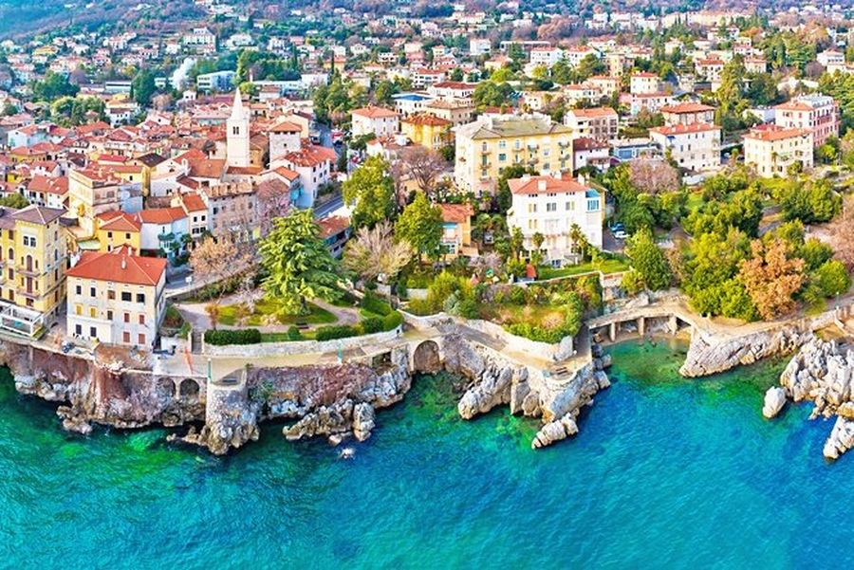

Number of participants 5 people (permanent workers and volunteers) aged 32-55 per Partner:
- Caritas AP – Poland (5 people)
- Udruga Enas - Croatia (8 people)
- EUROSUD – Italy (5 people)
- Non-governmental organization «Center for Social Activity «CIVITAS» - Ukraine (5 people)
- Caritas "Sv. Anastazija" Sremska Mitrovica Serbia (5 people)
Travel Budget:
Croatia | 180 euros/particpant
Ukraine | 275 euros /participant
Serbia | 180 euros /participant
Poland | 275 euros /participant
Italy | 275 euros /participant

Travel costs reimbursement:
Reimbursement is calculated based on the distance calculator of the European Commission.
At the arrival, all participants must provide flight reservation, all original tickets and boarding passes. They must send by post the return tickets and boarding passes to an email address which will be provided.

Project description:
With the transition of partner countries to the market economy, globalization of world markets, intensification of competition before domestic entities, problems arise in finding new
ways to ensure long-term existence and success. Today, strengthening basic skills and developing key competences for adults is a requirement of time. Often the key to success in the fight against competition is the social inclusion of disadvantaged groups.
The main goal of the Project is to educate adults on strengthening basic skills and developing key competences of socially excluded people. Specific objectives:
- identifying the educational needs of adults from disadvantaged groups
- activation and motivation of target group representatives to undertake active educational activities
- effective tools for raising key competences of adults
- promoting the concept of lifelong learning among adults
- strengthening basic skills representatives of disadvantaged groups
- developing the key competences of excluded people as the key to a better tomorrow
- presentation of examples of successfully implemented projects on adult education and social inclusion.
Participants:
- Short-term joint staff training events - 5 employees (including volunteers) from partner organizations (during 7 days),
- Blended mobility of adult learners - 5 adults, including the socially excluded from Poland, Croatia, Serbia and Italy (during 5 days).
Education in Project will contain 7 elements:
- 4 Short-term joint staff training events:
1. Identifying the educational needs of adults from disadvantaged groups
2. Activation and motivation of target group representatives to undertake active educational activities
3. Effective tools for raising key competences of adults
4. Promotion of the concept of lifelong learning among adults
- 3 Blended mobility of adult learners:
1. My basic skills
2. Education is the key to a better tomorrow
3. Examples of successfully implemented projects on adult education and social inclusion.

Classes implemented as part of the Project will be interactive, based not only on the transfer of knowledge, but primarily exercise through role-plays, quizzes, tests, presentations, case studies and seminars. Classes will include group and individual work. The trainers will be people who not only have knowledge and experience in the subjects they will discuss, but will be practitioners who use this knowledge in everyday life. In addition to strictly educational activities, participants will learn about the culture, art and history of the host countries, thanks
to which it will be possible to understand the national features of the Partners, get to know different cultures, and overthrow many stereotypes. This will definitely facilitate future transnational cooperation and strengthen European ties. The international nature of the Project will allow the transfer of good practices between participants to support personal development of representatives of disadvantaged groups.
As a result of participating in the Project, its participants:
- become acquainted with the methods of identifying the educational needs of adults from disadvantaged groups
- broaden their knowledge of the activation and motivation of target group representatives to undertake active educational activities
- learn about effective tools for raising key competences of adults
- broaden their knowledge of the promotion of lifelong learning among adults
- strengthen the basic skills of disadvantaged groups' representatives
- develop the key competences of excluded people as the key to a better tomorrow
- present examples of successfully implemented projects on adult education and social inclusion.
As a result of combined mobility, in which there will be almost half of participants with fewer opportunities, the barriers resulting from general stereotypes related to the personal development of socially excluded people will be leveled, key competences of participants will be developed. Socially excluded people will strengthen their faith in themselves, their own strength and the possibility of positive changes in their lives.
The results of the Project implementation will be actively used in the long term not only by direct participants of the project but also among other employees in organization to which the
participants will return. Electronic notes and a film on the project activities will be available for download on the Partners' websites and the Project fanpage and sent to the institutions of all Project participants. Not only people involved in supporting the personal development of socially excluded people will be able to use notes, qiuzs, tests, film and evaluation results, but also students, lecturers and other people interested in theoretical inclusion and social economy.

Name of the activity in Croatia:
Short-term joint staff training event “Identification of educational needs of adults from disadvantaged groups”

The aim of the first training program will be to thoroughly prepare participants to work towards
educating adults from disadvantaged groups. From the theoretical and practical side, knowledge and
experience will be transferred from the stage preceding educational activities - identifying the needs of
the target group representatives. Unfortunately, the identification of the needs of such a sensitive category of people take usually a minimum of time (and sometimes even vigor). It is usually recognized that their educational needs are identical to those of all members of society. A similar approach causes failure at the very beginning. When it comes to the personal development of adults from disadvantaged groups, which will result in their social inclusion, a similar omission can prove even more painful because socially excluded people are very vulnerable and often place a lot of hope in every single declaration of help. Failures allowed at the outset in identifying their educational needs may turn out to be very painful for society and for this category of people. Socially excluded people can break down and lose confidence and hope that their situation may change.
As a result, many of them will use alcohol or drugs, will violate the law, and will be destructive.
Trainers will present their own studies and available instruments, which will be supported by specific examples. During the training program, participants will learn:
- what are the educational needs of adults from disadvantaged groups,
- cooperation and communication with adults from disadvantaged groups, based on trust and support,
- how to conduct key analyzes to identify the educational needs of adults from disadvantaged groups.
Practical aspects of the above-mentioned issues will be tested with the help of non-formal education methods (games, quizzes, brainstorming). As a result, the topics discussed will allow a comprehensive approach to identifying the educational needs of the target group representatives.
Before starting the activity, participants from each partner organization prepare a presentation with concrete examples of how they identify the educational needs of adults from disadvantaged groups on a daily basis in their work. A presentation will be presented by each group during the training program. After its completion, the participants from each partner organization will present in their country (among representatives of local governments and NGOs) the most effective methods, instruments and techniques for identifying the educational needs of the target group representatives.
Project participants in thematic groups will draw on the help of experienced trainers and practitioners and improve their skills on interesting examples.
The first training program will be held in Rijeka (Croatia). The choice of this town is not accidental - in 2020 Rijeka is the European Capital of Culture.
The main three agenda themes of Rijeka 2020 are: water, work and migration. The last two are
directly related to social inclusion, ie the current Project. Rijeka – or “Port of Diversity” is a place full
of cultural and historical diversity, which is a symbol of symbiosis and openness. Participants of the
program from Croatia, Poland, Serbia, Italy and Ukraine will be able not only to deepen their competences but also to integrate with the help of events organized as part of Rijeka 2020 (From the
Cuisine of Diversity through the House of Children and Art on Lungomare, to discovering 27 local and
European neighbors).
Currency exchange
Currency in croatia is CROATIAN KUNA – 1 EURO is about 7,45 CROATIAN KUNA.

Weather
The weather is fairly mild in Lovran on February due to see side positin, but you should bring an extra layer of clothes with you because it is still a winter and it can be windy or rainy – so plese bring with yourself warm clothes and umbrela, also walking shoes.
Temperature: before your arrival please chech weather.

WHAT TO BRING:
What to bring with you?
1) Information about topic from your country
2) Materials of your organization
3) Good mood
4) Medicines and insurance;
5) Original travel e-tickets and invoices like train tickets, bus tickets etc.
6) Laptop, (or/and) camera
7) Food and drinks for intercultural night

Location and accommodation:

Hostel Link
Šetalište maršala Tita 9
51415 Lovran
Link: https://www.linkhostel.com/

You will be accomodated in 2 and 3 bed rooms with private toilet and shower in every room.
Hostel is located near see.
We will provide 3 meals per day (brakefast, lunch and dinner) – extra food or drinks will be on your own cost.

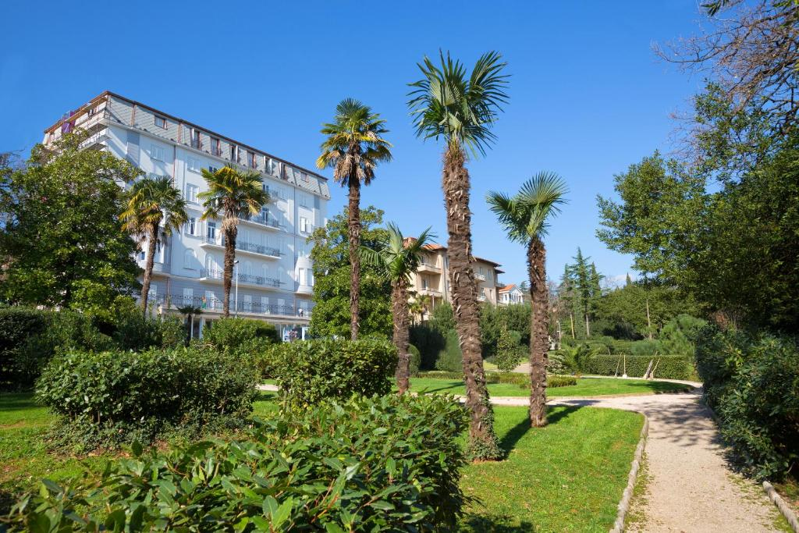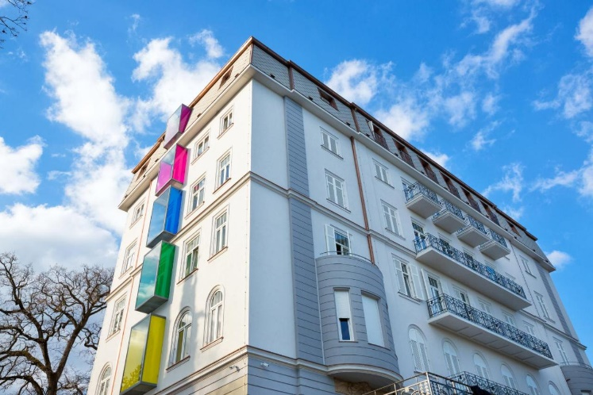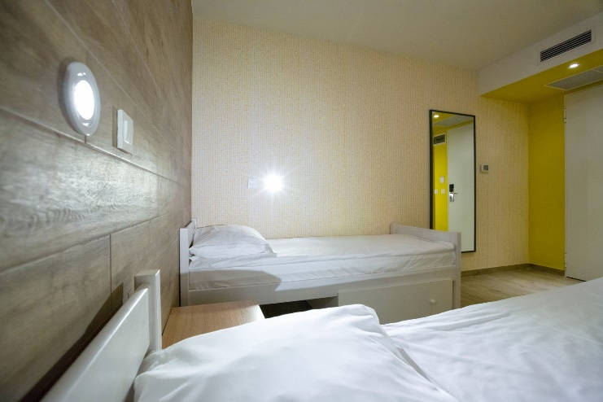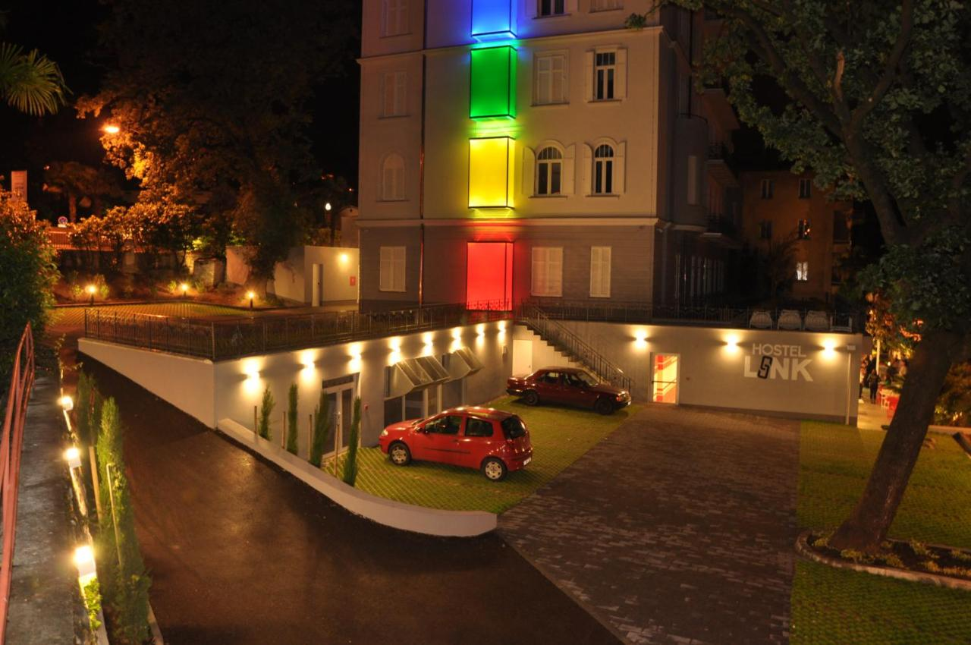

How to reach Venue?

The nearest airports that you can use is Zagreb airport. You can also explore Rijeka or Pula airport. We suggest you Zagreb because of connections.

When you arrive in Zagreb you should go to main bus station from airport (you have bus every 30 minutes from airport to main bus station).

When you arrive to main bus station you have almost every one hour bus to RIJEKA – you should go with that bus – or you can see also bus to OPATIJA.

When you arrive to Rijeka or to Opatija you should find a local bus number 32 and it will bring you directly to Lovran.

For more info, please contact: ivan.tomasic.lc@gmail.com

